Evaluating change and outcomes in Special FRIENDS
with children and young people with autism and/or learning disabilities
(from Slack, 2013)

Individualised/personalised approaches:

- A semi-structured interview schedule for identifying anxiety related behaviour in children and young people with autism and/or learning disabilities

- 4 examples of personalised observation approaches with instructions and recording sheets:

1 = Child C: beginning an individual task independently or with adult help (initiated by child or adult) - frequency count

2 = Child J: telling an adult about a ‘small problem’ ie unrelated to learning activity - frequency count

3 = Child C: frequency of being on/off task and interacting with peers/adults

4 = Child M: frequency of mouthing objects, hands resting or physical engagement in activity

Reproduced with permission of author from their doctoral research: Slack, G. (2013) An evaluation of the FRIENDS for Life intervention with an autistic spectrum population: evaluating the impact on children's anxiety. DAppEdPsy Thesis, University of Nottingham. Available at: http://eprints.nottingham.ac.uk/14520/1/602925.pdf
10 mins

Special FRIENDS
Semi-structured interview schedule for identifying anxiety related behaviour (from Slack, 2013)
Staff Member's Name: …………………………….. Staff Member's Role: …………………………………..
Child name: …………………………………………… Child's Class: ………………….
Observing and measuring anxiety related behaviour weekly before, during and after the FRIENDS groups intervention helps measure its effectiveness.
The measures can be taken by a member of school staff for efficiency and consistency.
Often the child's teaching assistant/teacher may be the ideal person to do this.
The measures aim to be short and straight forward to undertake.
The purpose of these questions is to gather information about child, specifically around their anxiety related behaviour, to create an individual observation schedule for each child around a specific target behaviour. This can be done within class, with parents, other folk involved.
It can be helpful to “triangulate” (compare/link) this information with other observations and information in school, therapy, psychology etc reports , family/carer reports and EHC Plans.
The information will help develop a personalised observation schedule. It can be useful to pilot (try out) for a couple of weeks to check the schedule is OK to use, and is measuring something useful.
Interview Questions
1) How would you know …….........was anxious? What anxiety related behaviours does he/she display? Can you describe the behaviour in detail?
.........................................................................................................................................................
.........................................................................................................................................................
.........................................................................................................................................................
.................................................................................................

2) When do these anxiety related behaviours most often occur in school?
.........................................................................................................................................................
.........................................................................................................................................................

3) What is the typical frequency of the behaviour?
.............................................................................................................................................. " .., .
...................................................................... , .
................................................................................................

4) How would you know if there was a reduction in anxiety?
.........................................................................................................................................................
.........................................................................................................................................................
................................................................

5) What strategies do the school currently use?
.........................................................................................................................................................
..........................................................................................................................................................................................................................................
.........................................................................................................................................................
......................................................

Do you have anything further to add that you think may be relevant?

Do you have any other questions?

Interviewer to feedback a summary of the information that has been provided and check with the interviewee that they have accurately understood/recorded the most relevant information.

Reproduced with permission of author from their doctoral research: Slack, G. (2013) An evaluation of the FRIENDS for Life intervention with an autistic spectrum population: evaluating the impact on children's anxiety. DAppEdPsy Thesis, University of Nottingham. Available at: http://eprints.nottingham.ac.uk/14520/1/602925.pdf
10 mins

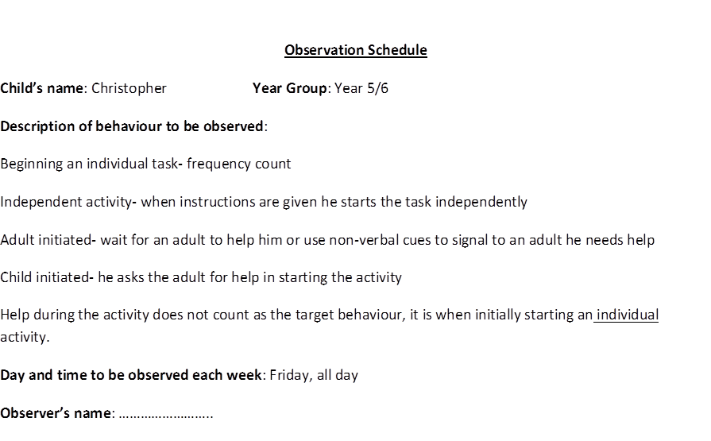
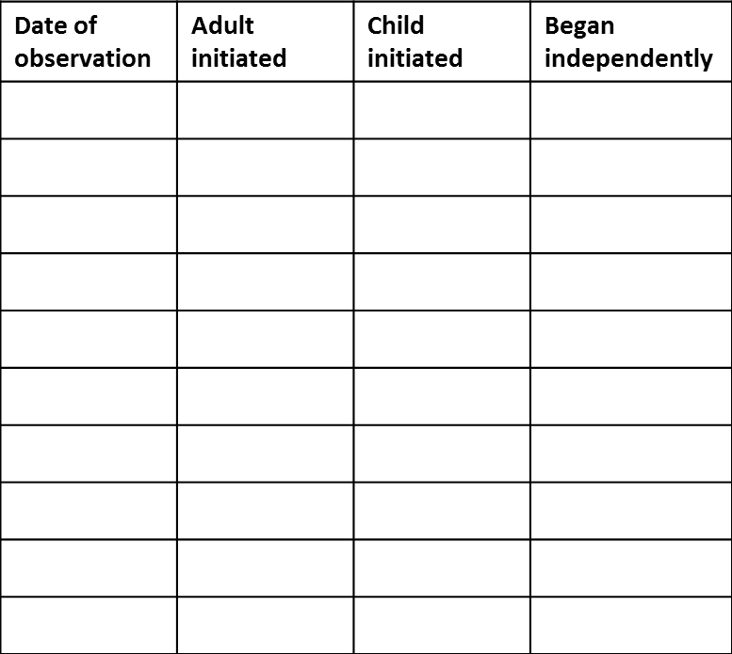
Observation Schedule: Example 1

Reproduced with permission of author from their doctoral research: Slack, G. (2013) An evaluation of the FRIENDS for Life intervention with an autistic spectrum population: evaluating the impact on children's anxiety. DAppEdPsy Thesis, University of Nottingham. Available at: http://eprints.nottingham.ac.uk/14520/1/602925.pdf
10 mins

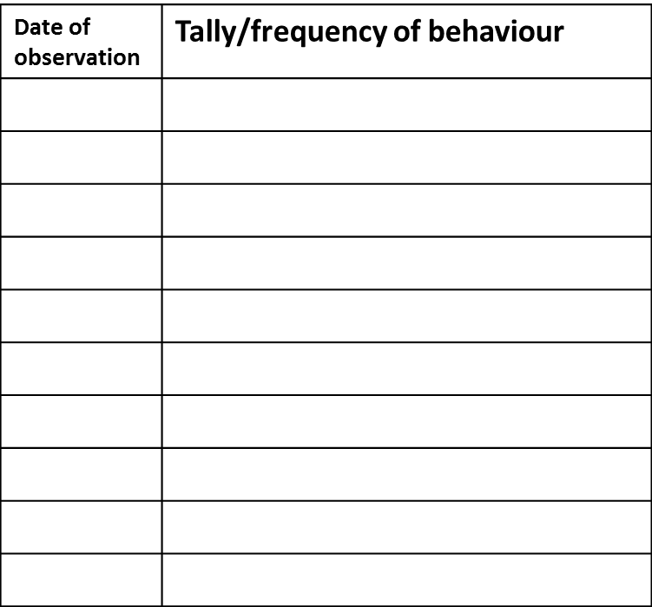

Reproduced with permission of author from their doctoral research: Slack, G. (2013) An evaluation of the FRIENDS for Life intervention with an autistic spectrum population: evaluating the impact on children's anxiety. DAppEdPsy Thesis, University of Nottingham. Available at: http://eprints.nottingham.ac.uk/14520/1/602925.pdf
10 mins

Observation Schedule: Example 3

Child’s Name: C Year: 4/5
Description of behaviour to be observed:
On task- working on the task that has been set or listening to teacher
On task seeking teacher or peer- Whilst working on task independently C seeks reassurance or assistance about his work from a peer or adult by either asking a question about the task or checking out what he is doing is right.
Off task (peer) - C is engaging in off task behaviour, not following instructions whether that be to listen or work independently. Instead he is interacting with other children in the class, not related to his task e.g. what are you doing?, or looking at others work to see what they are doing.
Off task (not peer) - not doing as been asked whether that be listening or doing a task. Off task behaviour that does not involve peers e.g. looking out window, moving around the classroom. If moving around the classroom speaking to other children or attempting to, that would be peer related.
Adult support- when he is working on an independent or group task with adult support. Does not include listening to adult instructions given to whole class but does include listening to adult instructions given specifically to him.
Observation day: …………………………. Observer: ……………………………………
Begin: ………….. End: …………….. Length of interval: every 10 seconds for 15 minutes
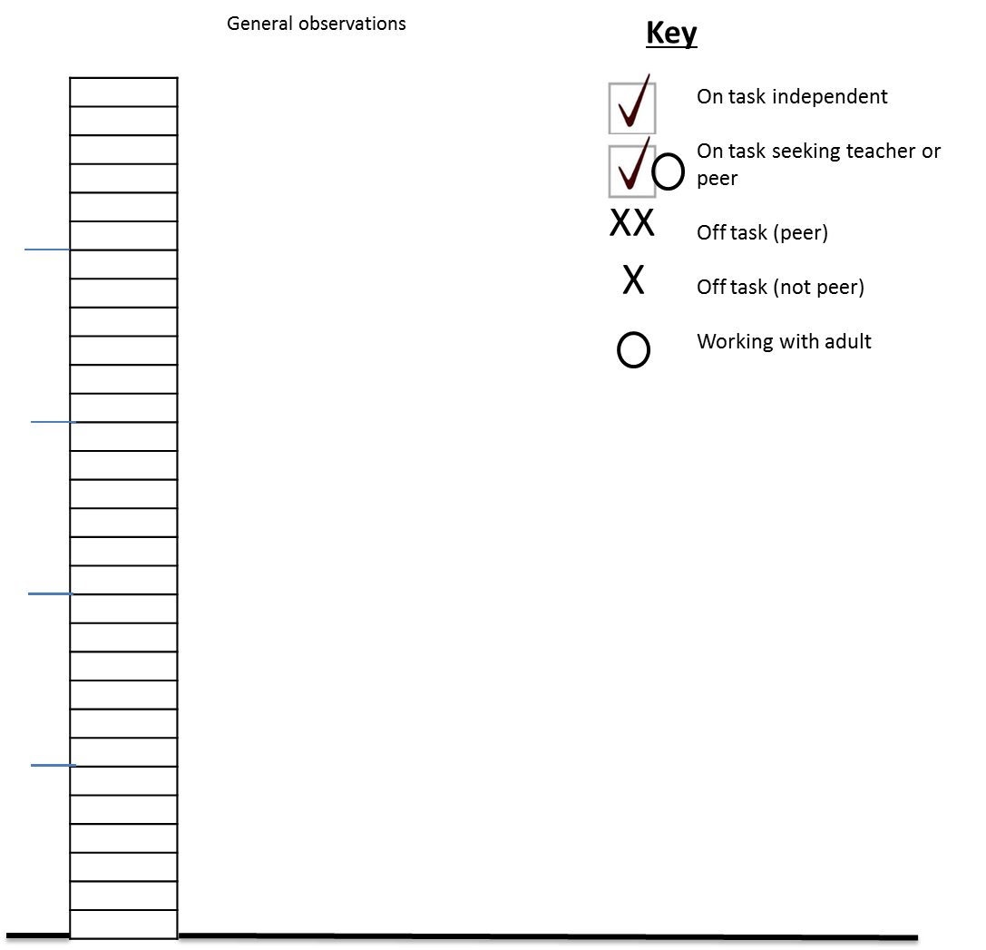

Reproduced with permission of author from their doctoral research: Slack, G. (2013) An evaluation of the FRIENDS for Life intervention with an autistic spectrum population: evaluating the impact on children's anxiety. DAppEdPsy Thesis, University of Nottingham. Available at: http://eprints.nottingham.ac.uk/14520/1/602925.pdf
10 mins

Observation Schedule: Example 4

Child’s name: M Year Group: Year 4/5
Description of behaviour to be observed:
Target behaviour- M is chewing, putting something in his mouth or touching mouth. This may involve one or both hands, maybe inside or touching mouth and includes behaviour such as nail biting. It also includes chewing objects such as a pen, inserting object into mouth, or touching mouth with object.
Hands resting- Hands are not moving or involved in an activity e.g. hands maybe down by side or resting on table while he listens to the teacher.
Physical activity- hands are being used as part of the activity e.g. writing but the target behaviour is not occurring.

Day and time to be observed each week: …………………… Observer’s name: ……………………………

Time begin: ………….. Time end: …………… Length of interval: every 20 seconds for 10 minutes
Circle dominant behaviour- either more chewing or more writing.
Over 50% is dominant.
Pen in and out of mouth= 1 second.
If both co-existing e.g. chewing jumper sleeve whilst writing, neither is dominant.
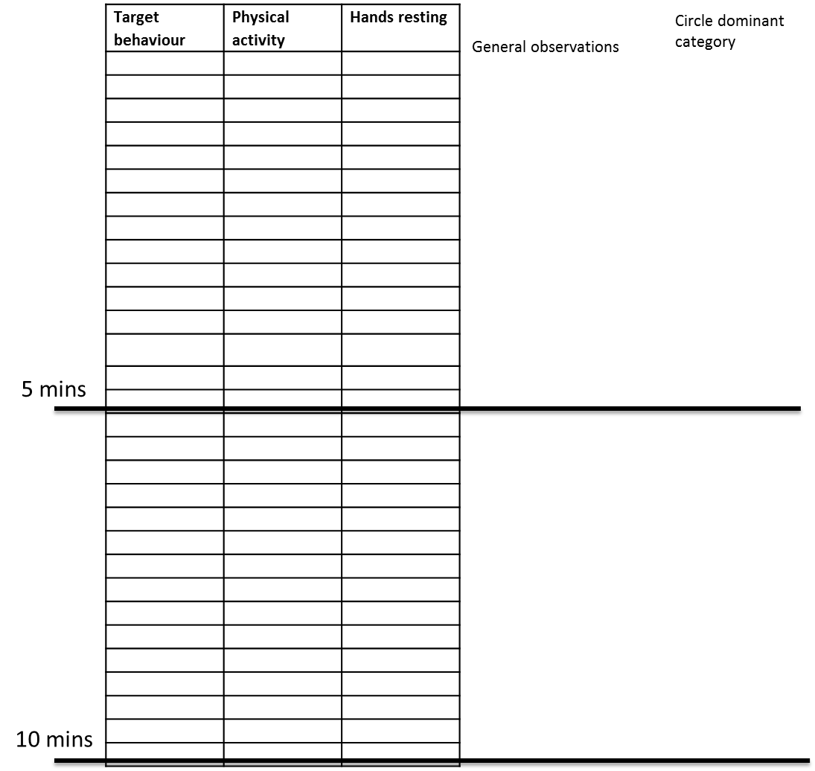

Reproduced with permission of author from their doctoral research: Slack, G. (2013) An evaluation of the FRIENDS for Life intervention with an autistic spectrum population: evaluating the impact on children's anxiety. DAppEdPsy Thesis, University of Nottingham. Available at: http://eprints.nottingham.ac.uk/14520/1/602925.pdf
10 mins

